SIMATS ENGINEERING

Department of Computer Science & Engineering
ASSESSMENT TOOL 1- EXPERIMENTS

Course Code: | CSA1205 | Course Title: | Computer Architecture for Multicore Systems
CO Assessed: | CO3 | Assessment: | ASSESSMENT TOOL 1-  EXPERIMENTS
Weightage: | 40% | Total Marks: | 25
CO3 Statement: | Design processor organization by constructing pipelined datapath structures, identifying hazard types (data, control, structural), and comparing superscalar techniques such as out-of-order execution, speculative execution, and simultaneous multithreading (SMT). (BL6)
Student Name: | Kavinadhithya R S | Reg.No.: | 192511365
Department: | B.E. CSE | Date:

ANNEXURE A

- Design and simulate a system that performs register transfer operations along with basic arithmetic and logic operations such as addition, subtraction, AND, and OR. Use multiple registers to demonstrate how data is transferred between them during execution, and analyze the sequence of operations and the role of the ALU in processing data.
- Create a model of a computer system using single-bus and multi-bus organization, and perform data transfer operations between registers, memory, and I/O. Compare the time taken and efficiency of both approaches, and analyze how multiple bus structures improve parallel data transfer and reduce bottlenecks.
- Simulate a 5-stage instruction pipeline (Fetch, Decode, Execute, Memory, Write-back) and execute a set of instructions. Measure the performance in terms of speedup and throughput, and compare it with a non-pipelined system to evaluate the effectiveness of pipelining.
- Develop a pipeline execution scenario where data hazards, control hazards, and structural hazards occur. Observe their impact on instruction execution, and implement techniques such as stalling, data forwarding, and branch prediction to resolve these hazards and improve performance.
- Analyze a processor supporting superscalar execution, including out-of-order and speculative execution, and extend the study to include hyper-threading and simultaneous multithreading (SMT). Evaluate how multiple instructions are executed in parallel and compare the performance improvements in terms of instruction throughput and resource utilization.

Code of Conduct:

I (Name / Reg No) certify that this submission is my original work and that I have adhered to the guidelines specified for this assessment.I understand that any violation of academic integrity rules will result in disciplinary action.

Signature of the student:

MARKS ALLOCATION

 | Understanding of Concepts (20%) | Experimental Design (20%) | Use of Tools  (25%) | Analysis of Results (20%) | Documentation  (15%)
Q1
Q2
Q3
Q4
Q5

RUBRICS FOR CALCULATION:

Criteria | Weightag e | Level 4 – Exemplary | Level 3 – Proficient | Level 2 – Developing | Level 1 – Beginning
Understanding of Concepts | 25 | Demonstrates thorough understanding and effectively integrates multiple  concepts/technologies | Good understanding with proper integration of most concepts | Basic understanding; limited or partial integration | Poor understanding; unable to  integrate concepts
Experimental Design | 30 | Well-planned, systematic implementation with optimal solution | Correct implementation with minor issues | Basic implementation with errors or  inefficiencies | Incorrect or incomplete  implementation
Use of Tools | 20 | Effective and advanced use of tools/technologies with proper configuration | Appropriate use of tools with correct execution | Limited or inconsistent use of tools | Incorrect or minimal use of tools
Analysis of Results | 15 | Insightful analysis with accurate interpretation and  validation of results | Good analysis with reasonable interpretation | Basic analysis with limited  insights | Poor or incorrect analysis of results
Documentation | 10 | Clear, well-structured documentation with diagrams, code, and results | Organized documentation with necessary details | Basic documentation with missing  details | Poor or  incomplete documentation

Register Transfer and ALU Operations Aim
To design and analyze a system that performs register transfer operations along with basic arithmetic and logic operations such as addition, subtraction, AND, and OR using multiple registers and an ALU.

Introduction
A register transfer operation is the movement of data from one register to another. The Arithmetic Logic Unit (ALU) performs arithmetic and logical operations on the data stored in registers. The Control Unit generates signals to select the required operation.

Block Diagram
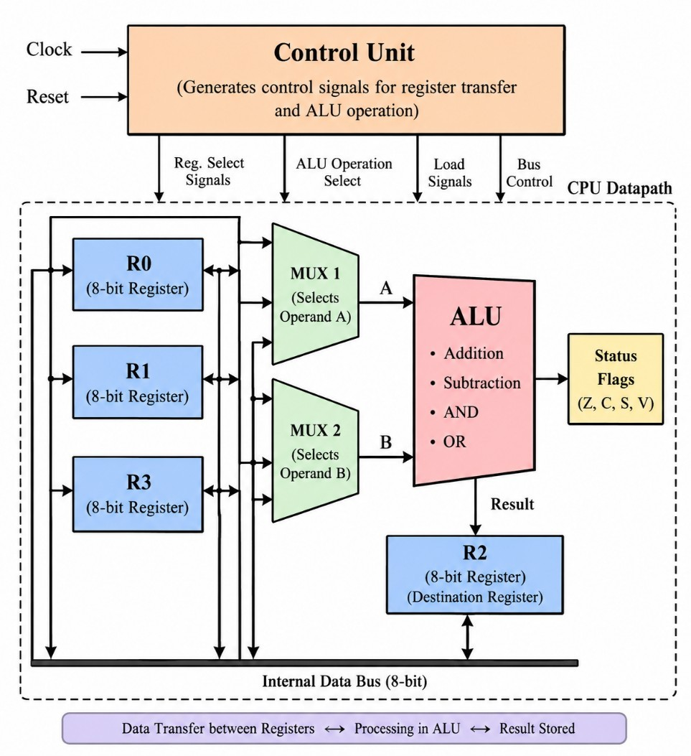

Register Organization
Assume four 8-bit registers:

Register | Function
R0 | First operand
R1 | Second operand
R2 | ALU result
R3 | Temporary register
Initial values:
R0 = 00001111 = 15
R1 = 00000011 = 3

Register Transfer
A register transfer is represented as:
R2 ← R0
This means the contents of R0 are transferred to R2. Example: R3 ← R0
Therefore:
R3 = 00001111

ALU Operations
- Addition R2 ← R0 + R1
00001111
+ 00000011

00010010
R2 = 18
- Subtraction R2 ← R0 − R1
00001111
- 00000011

00001100
R2 = 12

AND
R2 ← R0 AND R1
00001111
00000011

00000011
R2 = 3

OR
R2 ← R0 OR R1
00001111
00000011

00001111
R2 = 15

Operation Sequence

Step | Operation | Result
1 | R0 ← 15 | R0 = 15
2 | R1 ← 3 | R1 = 3
3 | R3 ← R0 | R3 = 15
4 | R2 ← R0 + R1 | R2 = 18
5 | R2 ← R0 − R1 | R2 = 12
6 | R2 ← R0 AND R1 | R2 = 3
7 | R2 ← R0 OR R1 | R2 = 15

Role of ALU
The ALU performs the required arithmetic and logical operations. The Control Unit selects the operation and the registers provide the operands.

Data flow:
Source Registers → ALU → Destination Register

The system successfully performs register transfers and addition, subtraction, AND, and OR operations. The role of the ALU and the sequence of data transfers between registers were analyzed successfully.

Single-Bus and Multi-Bus Organization Aim
To model and compare single-bus and multi-bus computer organizations for data transfer between registers, memory, and I/O, and analyze their performance.

Introduction
A bus is a communication path used to transfer data between different components of a computer. In a single-bus system, all components share one bus, whereas a multi-bus system uses multiple buses to allow parallel transfers.

Single-Bus Organization
All registers, ALU, memory, and I/O devices share one common bus. R0 ──┐
R1 ──┤
R2 ──┼──► SINGLE BUS ──► ALU Memory┤ │
I/O ─┘ ▼
Destination Example:
R1 ← R2
R2 → Bus → R1 For:
R3 ← R1 + R2
the operands must be transferred sequentially through the common bus.

Limitation
Since only one major transfer can use the bus at a time, the bus becomes a bottleneck.

Multi-Bus Organization
A multi-bus system uses multiple buses, allowing different data transfers to occur simultaneously.

R1 ──► Bus A ──┐
▼
ALU ──► Bus C ──► R3
▲
R2 ──► Bus B ──┘ For:
R3 ← R1 + R2
R1 and R2 can be transferred to the ALU simultaneously through Bus A and Bus B.

Register, Memory and I/O Transfers Register Transfer
R1 ← R2
R2 → Bus → R1 Memory Transfer R1 ← Memory
Memory → Bus → R1
I/O Transfer R1 ← I/O
I/O → Bus → R1
In a multi-bus system, independent transfers can use different buses at the same time.

Comparison

Feature | Single Bus | Multi Bus
Number of buses | One | Multiple
Data transfer | Sequential | Parallel
Speed | Lower | Higher
Hardware complexity | Low | High
Cost | Low | High
Bus bottleneck | High | Reduced
Parallelism | Limited | High
ALU utilization | Lower | Higher

Performance Example

Assume a particular sequence requires:
- Single-bus system = 7 clock cycles
- Multi-bus system = 4 clock cycles
Speedup:
Therefore, the multi-bus system is 1.75 times faster for this example.

Advantages of Multi-Bus Organization
- Allows parallel data transfer.
- Reduces bus contention.
- Reduces execution time.
- Improves ALU utilization.
- Increases overall throughput.
- Reduces communication bottlenecks.

Result
The single-bus and multi-bus organizations were successfully analyzed. The multi-bus structure provides better performance because multiple data transfers can occur in parallel.

Conclusion
A single-bus organization is simple and economical but suffers from a shared-bus bottleneck. A multi-bus organization is more complex and costly, but it improves parallelism, transfer speed, ALU utilization, and overall processor efficiency.

Five-Stage Instruction Pipeline Aim
To simulate a 5-stage instruction pipeline consisting of Fetch, Decode, Execute, Memory, and Write-back stages, and compare its performance with a non-pipelined processor.

Introduction
Pipelining is a technique in computer architecture where the execution of multiple instructions is overlapped. Instead of completing one instruction before starting the next, different instructions are processed in different stages simultaneously.
The five stages are:
  - IF – Instruction Fetch
  - ID – Instruction Decode
  - EX – Execute
  - MEM – Memory Access

  - WB – Write Back

Pipeline Stages

Stage | Function
IF | Fetches instruction from memory
ID | Decodes instruction and reads registers
EX | Performs ALU operation
MEM | Accesses data memory
WB | Writes result back to register

Example Instructions
Consider four instructions:
    - I1: R1 ← R2 + R3
    - I2: R4 ← R5 − R6
    - I3: R7 ← R1 AND R8
    - I4: R9 ← R10 OR R11

Pipeline Execution

Clock Cycle | I1 | I2 | I3 | I4
1 | IF
2 | ID | IF
3 | EX | ID | IF
4 | MEM | EX | ID | IF
5 | WB | MEM | EX | ID
6 |  | WB | MEM | EX
7 |  |  | WB | MEM
8 |  |  |  | WB
Thus, four instructions are completed in 8 clock cycles. Non-Pipelined Execution
In a non-pipelined processor, each instruction completes all five stages before the next instruction starts.

For 4 instructions:
Therefore:
    - Non-pipelined = 20 cycles
    - Pipelined = 8 cycles Speedup
Therefore, the pipelined processor provides a 2.5× speedup for this example.

Throughput
Throughput refers to the number of instructions completed per unit time.
After the pipeline is filled, approximately one instruction can be completed every clock cycle. Thus, pipelining significantly improves instruction throughput.

Advantages
    - Increases instruction throughput.
    - Improves processor resource utilization.
    - Allows multiple instructions to execute simultaneously at different stages.
    - Reduces the average time per instruction.

Result
The 5-stage instruction pipeline was analyzed successfully. Compared with a non-pipelined processor, pipelining reduces execution time and increases instruction throughput.

Conclusion
Instruction pipelining improves processor performance by overlapping the execution of multiple instructions. Although the first instruction still requires five stages, subsequent instructions can progress simultaneously through different stages, resulting in higher throughput.

Pipeline Hazards and Their Resolution Aim
To analyze data, control, and structural hazards in a pipelined processor and study techniques such as stalling, data forwarding, and branch prediction for resolving these hazards.

Introduction
A pipeline hazard is a condition that prevents the next instruction from executing in its normal clock cycle.

The three major types are:
- Data Hazard
- Control Hazard
- Structural Hazard

- Data Hazard
A data hazard occurs when an instruction depends on the result of a previous instruction. Example:
I1: R1 ← R2 + R3 I2: R4 ← R1 + R5
Here, I2 needs the value of R1 produced by I1.

Problem
I2 may try to read R1 before I1 has written the result.

Solution: Data Forwarding
The result from the EX stage of I1 is directly forwarded to the EX stage of I2. This reduces unnecessary waiting.

Control Hazard
A control hazard occurs due to a branch or jump instruction. Example:
I1: BEQ R1, R2, LABEL I2: ADD R3, R4, R5
The processor does not immediately know whether I2 should be executed because the branch decision is not yet available.

Solution: Branch Prediction
The processor predicts whether the branch will be:
  - Taken, or

Not taken
If the prediction is correct, execution continues without major delay.
If the prediction is incorrect, the incorrectly fetched instructions are removed from the pipeline.

Structural Hazard
A structural hazard occurs when two pipeline stages require the same hardware resource at the same time.
Example:
Instruction 1 → Memory access Instruction 2 → Instruction fetch
If the processor has only one memory unit, both operations cannot occur simultaneously.

Solution: Stalling
The processor temporarily pauses one instruction until the required resource becomes available. Cycle: 1 2 3 4 5
I1: IF ID EX MEM WB I2: IF ID ST EX
ST = Stall

Hazard Summary

Hazard | Cause | Example | Solution
Data | Data dependency | I2 uses I1 result | Forwarding / Stalling
Control | Branch instruction | Conditional branch | Branch prediction
Structural | Resource conflict | Same memory used twice | Stalling / Extra hardware

Effect of Hazards
Without hazard handling, the pipeline may produce incorrect results or require additional waiting cycles.
Hazards can:
- Increase execution time.
- Reduce throughput.
- Create pipeline stalls.
- Reduce processor efficiency.

Hazard Resolution Techniques
- Stalling

The processor inserts a delay or bubble into the pipeline.
Advantage: Simple and reliable.
Disadvantage: Increases execution time.

Data Forwarding
The required result is directly passed from one pipeline stage to another without waiting for write-back.
Advantage: Reduces data-related stalls.

Branch Prediction
The processor predicts the outcome of a branch before the actual result is known.
Advantage: Reduces control-hazard delays.

Overall Pipeline Flow
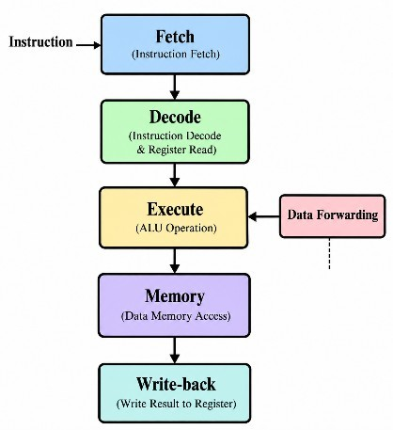
Branch prediction helps with control hazards, while stalling and forwarding help handle data and structural hazards.

Result
Data, control, and structural hazards were analyzed successfully. Stalling, data forwarding, and branch prediction were identified as techniques to reduce the performance loss caused by pipeline hazards.

Conclusion
Pipeline hazards can reduce the performance of a pipelined processor. Data forwarding reduces data dependency delays, branch prediction reduces control-hazard penalties, and stalling resolves situations where an operation cannot safely proceed. These techniques improve pipeline efficiency and maintain higher instruction throughput.

5. Superscalar, Out-of-Order, Speculative Execution and SMT Aim

To analyze a processor supporting superscalar execution, out-of-order execution, speculative execution, hyper-threading, and simultaneous multithreading (SMT) and evaluate their effect on instruction throughput and resource utilization.

Introduction
A superscalar processor can execute more than one instruction in a single clock cycle by using multiple execution units.
Out-of-order execution allows instructions to execute when their required operands and resources are available, rather than strictly following program order.
Speculative execution allows the processor to execute instructions before it is certain that they are required, usually based on branch prediction.
Hyper-threading/SMT allows multiple instruction streams or threads to share the resources of a single physical processor core.

Superscalar Execution
A superscalar processor contains multiple execution units.

For example, a 2-way superscalar processor may execute two independent instructions per clock cycle.

Out-of-Order Execution
In normal in-order execution:
I1 → I2 → I3 → I4
In out-of-order execution, if I2 is waiting for data but I3 is ready: I1 → I2 (waiting)
↓
I3 → I4
Thus, ready instructions can execute first.

Advantages
- Reduces processor idle time.
- Improves execution-unit utilization.
- Increases instruction-level parallelism.
- Improves overall throughput.

Speculative Execution
Speculative execution occurs when the processor predicts the result of a branch and executes instructions along the predicted path before the branch is confirmed.
If the prediction is correct, useful work has already been completed.
If the prediction is incorrect, the speculative results are discarded and the correct instructions are executed.

Hyper-Threading / SMT
Simultaneous Multithreading (SMT) allows multiple threads to share the resources of a single processor core.
When one thread is waiting for memory or another resource, another thread can use the available execution resources.

Example of Parallel Execution
Consider four independent instructions:

Instruction Operation

I1 | R1 ← R2 + R3
I2 | R4 ← R5 − R6
I3 | R7 ← R8 AND R9
I4 | R10 ← R11 OR R12
A single-issue processor may execute approximately one instruction at a time. A 2-way superscalar processor can execute:

Cycle Execution
1 I1, I2
2 I3, I4
Thus, four instructions can be completed in approximately 2 execution cycles, assuming no dependencies or resource conflicts.

Performance Comparison
Assume 8 instructions need to be executed.

Processor Type | Instructions/Cycle | Approx. Cycles
Single-issue | 1 | 8
2-way superscalar | 2 | 4
4-way superscalar | 4 | 2
For a 2-way superscalar processor:
Therefore, the ideal speedup is 2×.
In practice, the speedup is lower because of:
  - Data dependencies
  - Branches
  - Cache misses
  - Limited execution units
  - Resource conflicts

Effect on Resource Utilization

Technique | Main Benefit
Superscalar | Executes multiple instructions simultaneously
Out-of-order | Uses idle execution units efficiently
Speculative execution | Reduces branch waiting time
SMT/Hyper-threading | Uses unused resources between threads
These techniques work together to increase processor utilization and instruction throughput.

Overall Comparison

Feature | Basic Processor | Advanced Processor
Instruction issue | One at a time | Multiple

Feature | Basic Processor | Advanced Processor
Execution order | Mostly in order | Out of order
Branch handling | Normal | Speculative
Threads/core | Usually one | Multiple
Parallelism | Low | High
Throughput | Lower | Higher
Resource utilization | Lower | Higher

Result
The analysis shows that superscalar execution, out-of-order execution, speculative execution, and SMT significantly improve instruction-level and thread-level parallelism. Multiple instructions can be processed simultaneously, increasing instruction throughput and making better use of processor resources.

Conclusion
A modern processor improves performance by combining multiple techniques. Superscalar execution increases the number of instructions executed per cycle, out-of-order execution keeps execution units busy, speculative execution reduces branch delays, and SMT/Hyper-threading allows multiple threads to share processor resources. Together, these techniques improve instruction throughput, parallelism, and resource utilization.

